Precent Layout

1. Tạo project. Nhúng percent

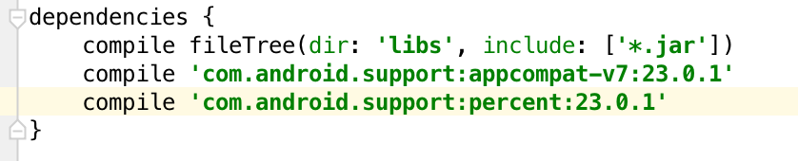

# PrecentRelativeLayout

1. Trong file layout viết như sau:

<**android.support.percent.PercentRelativeLayout  
 xmlns:android="http://schemas.android.com/apk/res/android"  
 xmlns:app="http://schemas.android.com/apk/res-auto"  
 android:layout_width="match_parent"  
 android:layout_height="match_parent"**>  
  
 <**View  
 android:id="@+id/top_left"  
 android:layout_width="0dp"  
 android:layout_height="0dp"  
 android:layout_alignParentTop="true"  
 android:background="#ff44aacc"  
 app:layout_heightPercent="20%"  
 app:layout_widthPercent="70%"** />  
  
 <**View  
 android:id="@+id/top_right"  
 android:layout_width="0dp"  
 android:layout_height="0dp"  
 android:layout_alignParentTop="true"  
 android:layout_toRightOf="@+id/top_left"  
 android:background="#ffe40000"  
 app:layout_heightPercent="20%"  
 app:layout_widthPercent="30%"** />  
 <**View  
 android:id="@+id/bottom"  
 android:layout_width="match_parent"  
 android:layout_height="0dp"  
 android:layout_below="@+id/top_left"  
 android:background="#ff00ff22"  
 app:layout_heightPercent="80%"** />  
  
</**android.support.percent.PercentRelativeLayout**>

1. Chuyển sang Design thấy giao diện

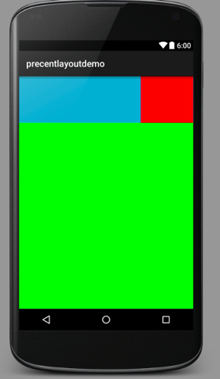

# PercentFrameLayout

1. Sửa source layout lại

<**android.support.percent.PercentFrameLayout  
 xmlns:android="http://schemas.android.com/apk/res/android"  
 xmlns:app="http://schemas.android.com/apk/res-auto"  
 android:layout_width="match_parent"  
 android:layout_height="match_parent"**>  
 <**View  
 android:layout_width="0dp"  
 android:layout_height="0dp"  
 android:background="#ff44aacc"  
 app:layout_heightPercent="20%"  
 app:layout_widthPercent="60%"**/>  
  
 <**View  
 android:layout_width="0dp"  
 android:layout_height="0dp"  
 android:background="#ff4400cc"  
 app:layout_heightPercent="10%"  
 app:layout_widthPercent="70%"**/>  
</**android.support.percent.PercentFrameLayout**>

1. Giao diện sẽ thành

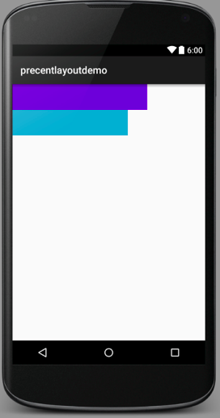

Cách thuộc tính percent

* heightPercent
* widthPercent
* marginBottomPercent
* marginEndPercent
* marginLeftPercent
* marginPercent
* marginRightPercent
* marginStartPercent
* marginTopPercent